**Crowdfunding Campaigns –**

**Are they just a “fad du jour”? If not, when do they deliver on their goals?**

**Executive Summary of Insights:**

* The sample data of 1000 Crowdfunding Campaigns is dominated by the US market campaigns, which represents 76.3% of the data.



* Regardless of country, the top 3 types of crowdfunding categories are for Theater (specifically *Plays* at 34.4% of total campaigns), Film & Video, and Music campaigns. In Australia, Technology campaigns surpass Music campaigns; however, one needs to be cautious in making conclusions given that the total number of campaigns are small in general in Australia (a total of 43 out of 1000). *Please refer to the enclosed spreadsheet, Outcome Type by Category tab, and filter on Country, selecting AU.*

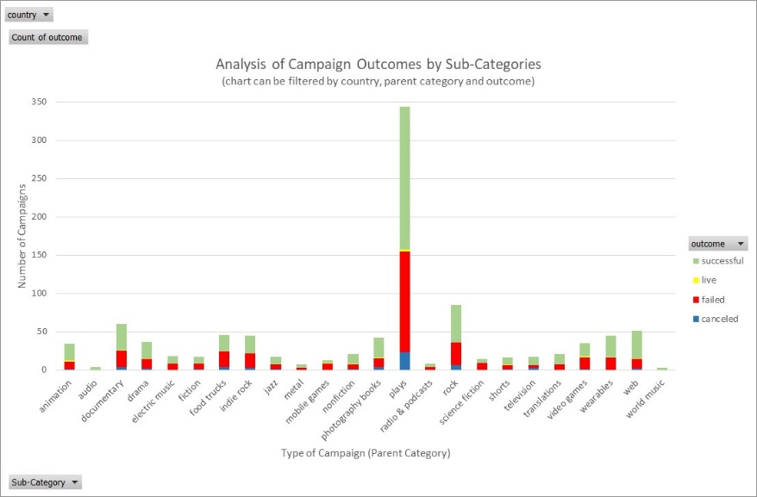

* In general, crowdfunding campaigns are most successful in the months of June and July, and least successful in August (reflects the lowest number of successful campaigns and second highest number of failed campaigns). However, that trend does not hold for all the years from 2010-2020. For example, in 2011, April is the worst month for Crowdfunding campaigns. *One needs to be cautious in making conclusions given that the total number of campaigns are small within each year, approximately 100 campaigns per year (only 2 total campaigns in 2020).*

* Furthermore, depending on the category of crowdfunding, certain months were better than others for conducting a successful campaign. For example, for funding music projects the months of July, November and December were better months for a successful campaign outcome. That observation could be a resulting outcome of the Holiday Season (4th of July, Thanksgiving and Christmas seasons), but will require further assessment of possible latent factors for success. *Please refer to the enclosed spreadsheet, Outcome by month_year_Category tab, and filter on year and category.*

**Limitations of the Dataset:**

* As mentioned earlier, the sample data of 1000 Crowdfunding Campaigns is dominated by the US market campaigns, representing 76.3% of the data, which becomes a challenge for making any conclusions at a county level.

* It is unclear from the dataset whether the variable labeled “goal” reflects US dollars or it is in the currency stated in the variable labeled “currency”. If it is the latter, then the variable “goal” needs to be represented in US dollars utilizing an exchange table at a certain date, which would be a challenge given the different year and month sources of the data.
* A sample of 1000 crowdfunding campaigns is too small to enable mining the data by any combination of country, year and month, subcategory, # of backers, goals, etc. The deep-dive analysis will result in very small data counts to make any statistically significant conclusions.

**Recommended further analyses:**

* Comparison among successful and failed campaigns, across multiple factors (caution will need to increase sample size first).
* Comparison across years and months (caution will need to increase sample size first). Conduct time series analysis to understand the effects of seasonality on campaigns.
* Comparison across countries (caution will need to increase sample size first) and use weighted average type of analysis.
* If “Goal” is not stated in US currency, then use exchange tables for each month and year before conducting any analysis of campaign goals.
* Comparison across “clusters” of sub-categories of campaigns (caution will need to increase sample size first).